How to create pie chart, bar chart and line chart in SSRS.

Create Bar Chart, Pie chart and Line Chart in SSSR

Pie chart:

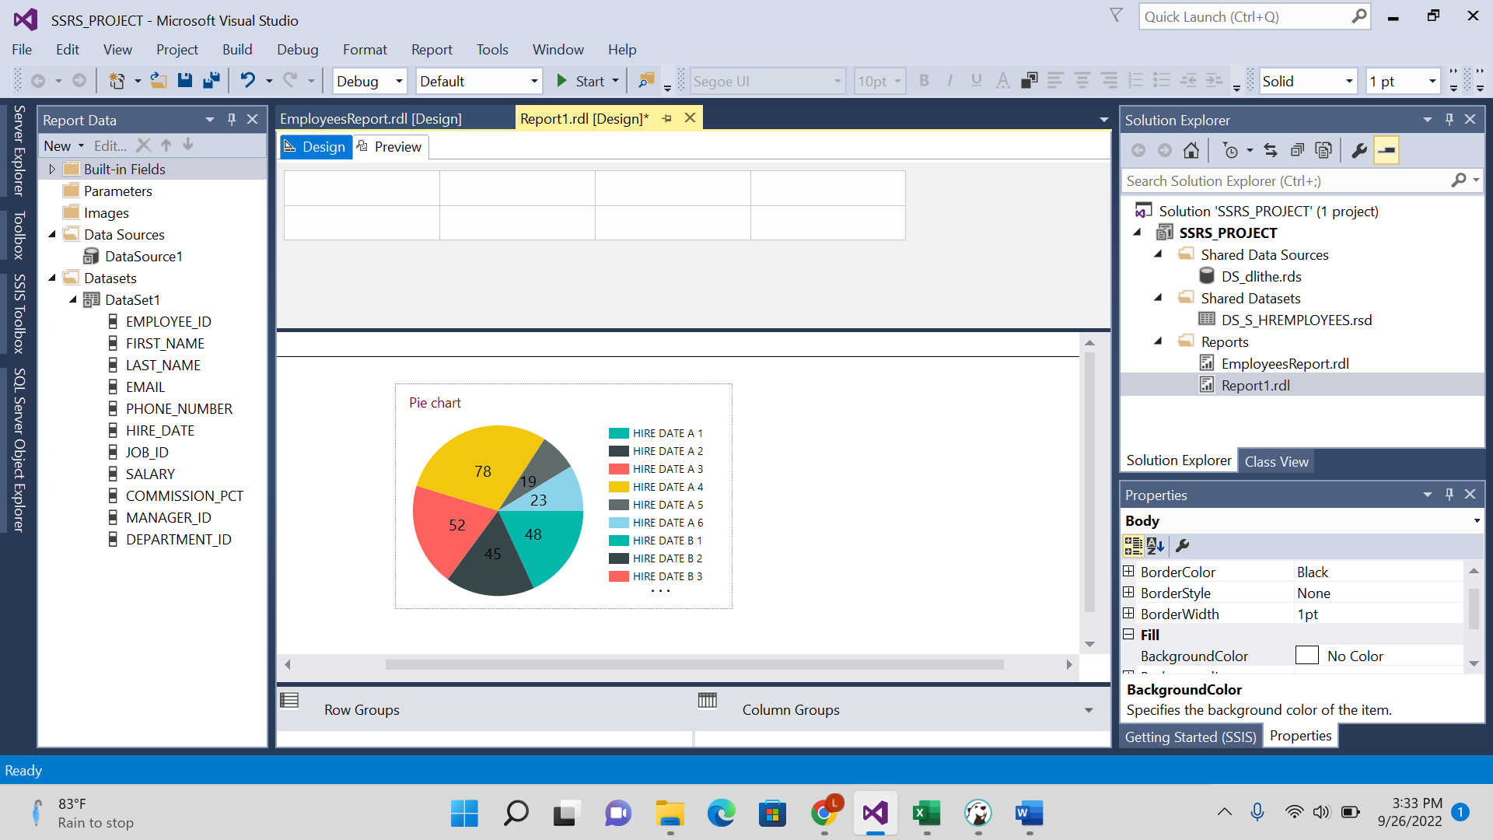

Bar chart:

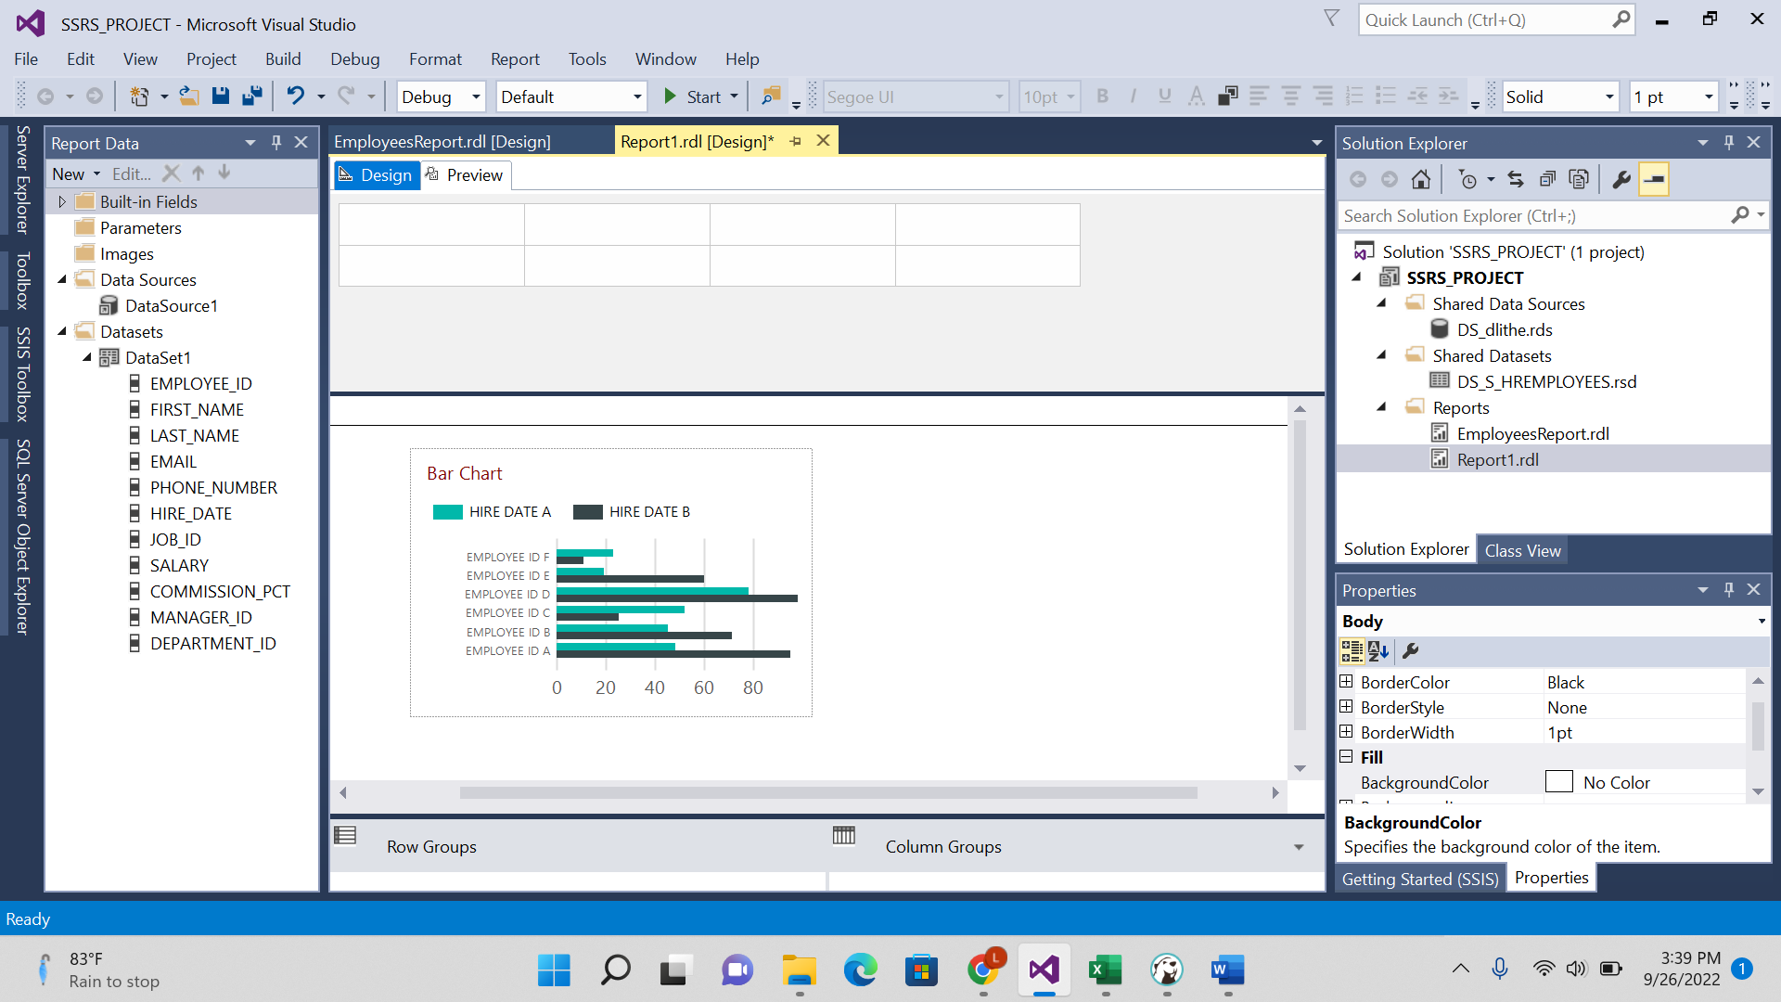

Line Chart:



